**A Petri Net Model of Internal Organs and Twelve Principal Meridians**

GAN Quan**\***, WU Ren**\*\***, NAKATA Mitsuru**\*\***, GE Qi-Wei**\*\***

（Abstract）

In this paper, we aim to construct a Petri net model of human internal organs and meridians. In the previous studies, we proposed a Petri net model for five viscera and six bowels including triple energizer and a combined model with Pericardium and Kidney Meridians. In this paper, we propose methods of constructing a combined Petri net model of five viscera…

Keywords: internal organs, meridians, twelve principal meridians, Petri net, modeling

* Graduate School of Education, Yamaguchi University

** Yamaguchi Junior College

*** Faculty of Education, Yamaguchi University

*Journal of East Asian Identities Vol. XX March 20XX （pp. XX-XX）*

**1. Introducation**

Traditional Chinese medicine or oriental medicine has been widely applied in treating disease since ancient times. This is because its less secondary effect as well as its possible curing for ahead sick and incurable disease. Especially acupuncture and moxibustion therapy have spread rapidly since the time when acupuncture and moxibustion therapy were admitted by WHO in 1989 and 361 acupuncture points were standardized by WHO in 2006[1]. Therefore establishment of acupuncture and moxibustion treatment unified by new knowledge is required [1]. Till now, many studies have been done to clarify the mechanism of the human body and meridians…

**2. Five-Elements Theory and Petri Nets**

In this section, five-elements theory of traditional Chinese medicine and Petri Nets are introduced to …

**2.1 Five-elements theory**

According to ancient Chinese five-elements theory, the five elements, wood (木), fire (火), earth (土), metal (金) and water (水) are indispensable to the daily life of mankind. And in five-elements theory of traditional Chinese medicine, five viscera, liver (肝), heart (心), spleen (脾), lung (肺) and kidney (腎), are mapped to the five elements respectively. Liver flow Qi (気) through over the body free of all care, as a tree getting longer; Heart warm the body as fire; Spleen produce nutrients, as soil that produce all things; Lung take down Qi and Bodily Fluid (津液), as astringent action of the metal; Kidney pool Mind (精) and adjust the moisture of the body, as water that flows to the low place from on high…

**2.2 Petri Nets and Colored Petri Nets**

A Petri net is one of several mathematical modeling languages for the description of concurrent systems. A Petri net is a weighted directed bipartite graph and consists of two types of nodes, transitions (i.e. events that may occur, signified by bars) and places (i.e. conditions, signified by circles).

 Figure 1: The interrelationship of five viscera.

**3. A Petri Net Model with Twelve Principal Meridians**

In this section, we discuss how to construct a Petri net model of five viscera and…

**3.1 Idea of Overall Model**

Till now, a Petri net model of five viscera and six bowels including triple energizer with only pericardium meridian has been constructed. However, it does not include all the twelve principal meridians. Therefore, a Petri net model of five viscera and six bowels with the twelve principal meridians need to be built. In the references, only one meridian is taken into account. In order to model all the meridians, it is necessary to have an interface which combines the twelve meridians with five viscera and six bowels. By stimulating multiple acupuncture points that belong to the twelve meridians, the values should be calculated and delivered to each viscus…

**3.2 The Twelve Principal Meridians**

To control all the acupuncture points easily, hierarchy for twelve principal meridians is created…

Table 1. Acupuncture points and internal organs.

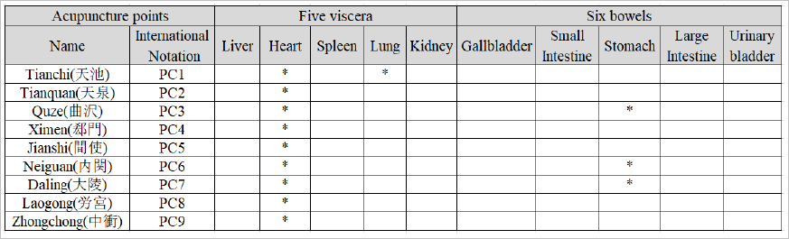

**4. Simulation and Its results**

In this section, the simulation using our model is descripted and the results are discussed to …

**4.1 Report Files and Program**

The results of the simulation by using CPN Tools can be written into text files. By setting the output of log information in advance for each place or transition, the related file for each place or transition can be created. These files are called log files…

**4.2 Experimental Results**

Simulation has been done by using CPN Tools for the model. State value of each organ is defined in (0.5,5.5) that is divided into five domains which represent five states, weak, little weak, equilibrium, little strength and strength respectively…

**5. Conclusions**

We have proposed a method of constructing integrated Petri net models for five viscera and six bowels and twelve principal meridians based on affecting of the acupuncture points to the internal organ. Furthermore, …

**Acknowledgement**

This work was supported by JSPS KAKENHI Grant Number JP16KXXXXX (Grant-in-Aid for Challenging Exploratory Research).

**References**

[1] S. Shinohara, “A proposal of the 2nd Japan Meridian and Point Committee”, Ido No Nippon, vol.71, no.5, pp.142-154 (2012) (in Japanese).

[2] X.W. Li, Y.M. Wang, X. Liu and Y. Zhang, “The summarization on the quantitative models of five elements”, BME & Clin Med., vol.16, no.4, pp.411-414 (2012) (in Chinese).

[3] C.L. Sun, X.Y. Li and L.C. Zhao, “Fuzzy modeling and analysis based on five elements theory for the system of five organs system”, Journal of Anshan Normal University, vol.13, no.6, pp.1-4 (2011) (in Chinese).

[4] W.Y. Guo, J.Q. Wu and S. Wang, “Five elements system modeling and solving", Journal of Shanghai Second Polytechnic University, vol.25, no.4, pp.253-256 (2008) (in Chinese).

[5] P.A. Heng, T.T. Wong, R. Yang, Y.P. Chui, Y. Xie, K.S. Leung and P.C. Leung, “intelligent inferencing and peptic simulation for Chinese acupuncture learning and training ”, IEEE Trans. Inf. Technol. Biomed., vol. 10, no. 1, pp. 28-41 (2006)

[6] J. Pan and M. Zhou, “Modeling and analysis of meridian systems using Petri nets”, International Journal of Intelligent Control and Systems, vol. 10, no. 3, pp. 226-234 (2005)

[7] J.L. Peterson, Petri Net Theory and the Modeling of Systems, Prentice Hall, Englewood Cliffs, NJ, USA (1981).

**Appendix**

**A.1 Margin**

Top and Bottom: 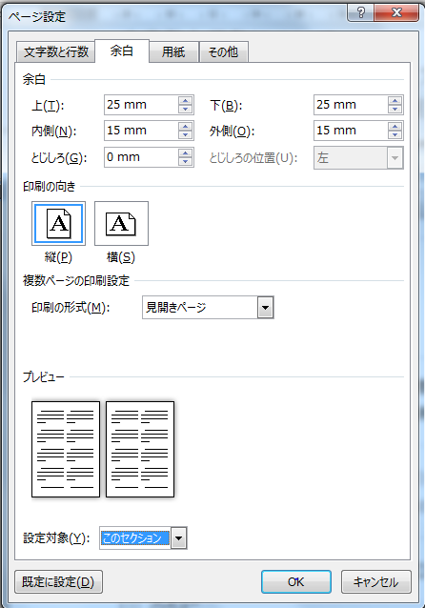25mm; Left and Right: 15mm (Refer to Fig. A-1)．

Fig. A-1 Setting Margin

**A.2 Number of columns and lines**

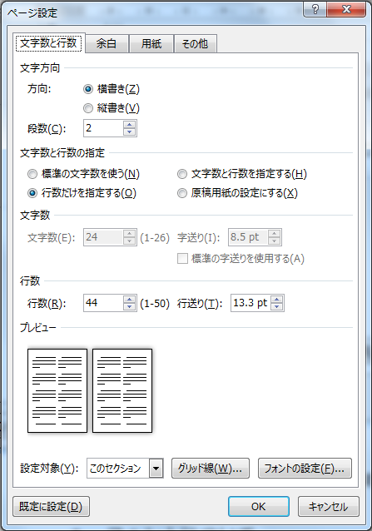2 columns and 44 lines per page (Refer to Fig. A-2).

Fig. A-2 Setting columns and lines

**Fonts**

Font of text: Times New Roman 8.5pt.

〈Author Biography〉

GAN Quan: received the B.E. from XX University in 20XX, and the M.E. from XX University in 20XX. Currently…

WU Ren: received the B.E. and M.E. from XX University in 19XX and 19XX, respectively, and the Ph.D. from XX University in 20XX. Currently, …

NAKATA Mitsuru: received the B.E., M.E. and Ph.D. from XX University in 19XX, 19XX and 19XX, respectively. Currently, …

GE Qi-Wei: received the B.E. from XX University, in 19XX, the M.E. and the Ph.D. from XX University in 19XX and 19XX, respectively. Currently, …

1. Footnotes will be placed here.